

Semester One

Examination 2018

Question/Answer booklet

MATHEMATICS
APPLICATIONS UNIT 1

Section One:
Calculator–free

Student Name: _____________________________________
Teacher’s Name: _____________________________________

Time allowed for this section
Reading time before commencing work: five minutes
Working time for paper: fifty minutes

Material required/recommended for this section

To be provided by the supervisor
This Question/Answer booklet
Formula Sheet

To be provided by the candidate
Standard items: pens (blue/black preferred), pencils (including coloured), sharpener, correction tape/fluid, eraser, ruler, highlighters

Special Items: nil

Important note to candidates
No other items may be taken into the examination room. It is your responsibility to ensure that you do not have any unauthorised notes or other items of a non–personal nature in the examination room. If you have any unauthorised material with you, hand it to the supervisor before reading any further.

Structure of this paper

 | Number of questions available | Number of questions to be attempted | Working time (minutes) | Marks available | Percentage of exam
Section One  Calculator—free | 6 | 6 | 50 | 50 | 35
Section Two  Calculator—assumed | 14 | 14 | 100 | 100 | 65
 |  |  |  | Total marks | 100

Instructions to candidates

- The rules for the conduct of Western Australian external examinations are detailed in the
Year 12 Information Handbook 2018. Sitting this examination implies that you agree to abide by these rules.

- Answer the questions according to the following instructions.

Show all your working clearly. Your working should be in sufficient detail to allow your
answers to be checked readily and for marks to be awarded for reasoning. Incorrect answers given without supporting reasoning cannot be allocated any marks. For any question or part question worth more than two marks, valid working or justification is required to receive full marks. If you repeat an answer to any question, ensure that you cancel the answer you do not wish to have marked.

It is recommended that you do not use pencil, except in diagrams.

- You must be careful to confine your responses to the specific questions asked and to follow any instructions that are specific to a particular question.

- Spare pages are included at the end of this booklet. They can be used for planning your responses and/or as additional space if required to continue an answer.
- Planning: If you use the spare pages for planning, indicate this clearly at the top of the page.
- Continuing an answer: If you need to use the space to continue an answer, indicate in the original answer space where the answer is continued, i.e. give the page number. Fill in the number of the question that you are continuing to answer at the top of the page.

- The Formula Sheet is not handed in with your Question/Answer Booklet.

Section One: Calculator–free 35% (50 marks)

This section has six (6) questions. Attempt all questions. Write your answers in the spaces provided.

Spare pages are included at the end of this booklet. They can be used for planning your responses and/or as additional space if required to continue an answer.

- Planning: If you use the spare pages for planning, indicate this clearly at the top of the page.
- Continuing an answer: If you need to use the space to continue an answer, indicate in the original answer space where the answer is continued, i.e. give the page number. Fill in the number of the question(s) that you are continuing to answer at the top of the page.

Working time: 50 minutes

Question 1 (7 marks)

(a) Calculate the simple interest on $500 for 2 years at 8% pa. (2 marks)

(b) What equation, when solved, would allow you to calculate the rate of interest
a lender must charge to obtain $500 simple interest over 4 years on a principal
of $2000? (2 marks)

After 3 years, a principal of $1000 grows to become $1200, when invested at 6% pa compounding at x times per year.
The formula which applies to this situation is 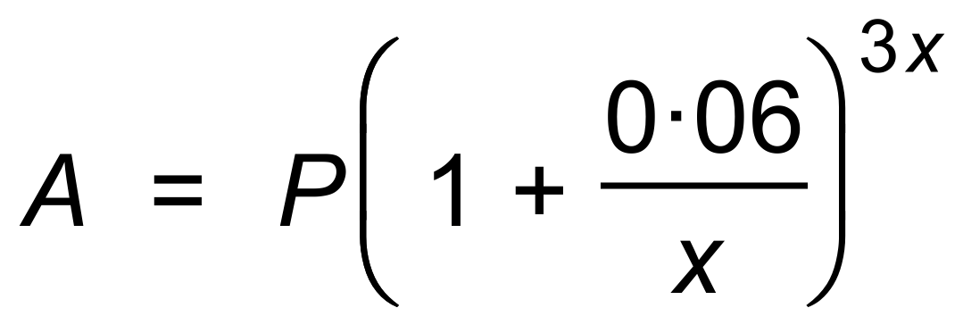
State the values of:

(i) P (1 mark)

(ii) the compound interest earned. (1 mark)

(iii) A (1 mark)

Question 2 (14 marks)

(a) Calculate M where M = XY + 5 with X = 6 and Y = 2. (1 mark)

(b) Calculate N where N = (x + y)² with x = 6 and y = 2. (1 mark)

(c) Calculate the simple interest received on an investment of $4500 at the end of 5 years, with interest at a rate of 3.2% p.a. (2 marks)

(d) Determine the GST of 10% to be added on a sale of $75. (1 mark)

(e) Peter pays $88 for an item. This includes 10% GST.
What was the price of the item before GST? (2 marks)

(f) What percentage of 120 is 30? (2 marks)

(g) Chloe’s netball team scored 25 goals in a final. The opposing team scored 20% more.
What was the opposing team’s score? (2 marks)

(h) 5% of a length of wire was removed. 285 m of wire remained.
What length of wire was removed? (3 marks)

Question 3 (8 marks)
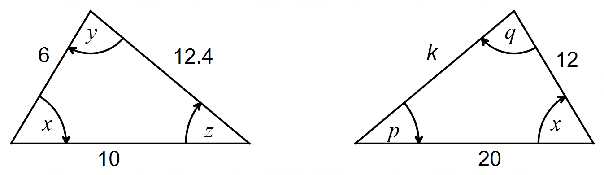

(a) (i) Show that these two triangles are similar to each other. Lengths are in cm, and
the angles are in degrees. (3 marks)

(ii) Determine the value of k. (2 marks)

(b) (i) State the value of p + q in terms of y and z. (1 mark)

(ii) State the value of the expression x + y + z. (1 mark)

(c) The area of the smaller triangle is A.
What is the area of the larger triangle, in terms of A? (1 mark)
Question 4 (9 marks)

Consider these four matrices.

A = 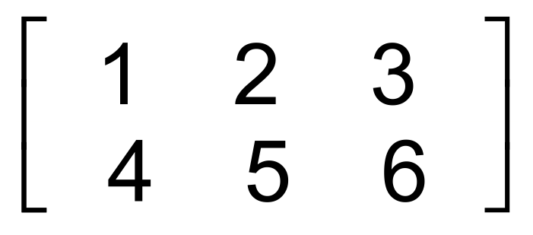 B = 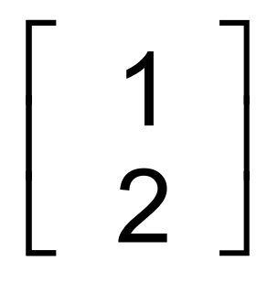 C = 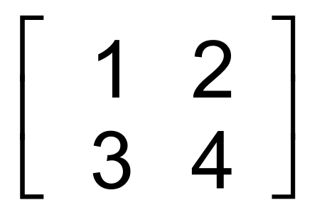 D = 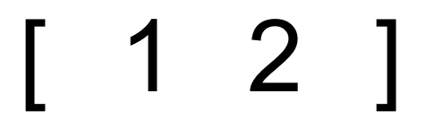

(a) State the dimensions of matrix A. (1 mark)

(b) Calculate, if possible:

(i) CB (2 marks)

(ii) BD (2 marks)

(iii) 2A (2 marks)

(iv) −C − 2C (2 marks)

Question 5 (5 marks)

Two balloons are inflated so that their radii are in the ratio of 3:4.
The larger balloon has a radius of 80 cm.

(a) State:

(i) the radius of the smaller balloon. (1 mark)

(ii) the ratio of their surface areas. (1 mark)

(iii) the ratio of their volumes. (1 mark)

(b) State, in terms of π, the surface area of the larger balloon. (2 marks)

Question 6 (7 marks)

This network (digraph) shown below represents roads between locations in a city.
Some roads are two−way, and some are one-way. Arrows indicate the direction of the
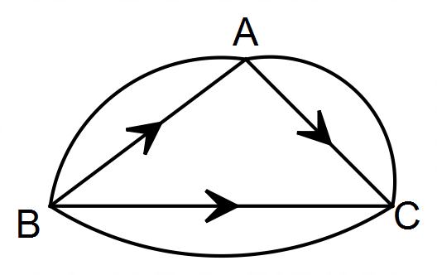one−way roads.

(a) Enter the same information shown above into matrix M. (2 marks)
 |  |  |  | To
 |  |  |  | A B C
 |  | A
M = | From | B
 |  | C

(b) Use matrix multiplication to determine matrix M². (2 marks)

(c) In this context, what information is contained in matrix M²? (1 mark)

(d) (i) In how many ways can a person travel from A to B, using two paths? (1 mark)

(ii) Which place (vertex), if any, cannot be reached from C in two stages? (1 mark)

End of Questions
Additional working space

Question number(s): ……………………

Additional working space

Question number(s): ……………………

Additional working space

Question number(s): ……………………

WATP acknowledges the permission of the School Curriculum and Assessment Authority in providing instructions to students.

